message_frequency = 500;

sampling_frequency = 2000;

num_samples = 100;

bit_depths = [8, 10];

T = 1 / sampling_frequency;

duration = num_samples * T;

t = linspace(0, duration, num_samples);

message_signal = sin(2*pi*message_frequency*t);

sampled_signal = message_signal;

quantize = @(x, levels) round((x + 1) * (levels - 1) / 2) * 2 / (levels - 1) - 1;

quantized_signals = cell(length(bit_depths), 1);

for i = 1:length(bit_depths)

bit_depth = bit_depths(i);

levels = 2^bit_depth;

quantized_signal = quantize(sampled_signal, levels);

quantized_signals{i} = quantized_signal;

end

encoded_signals = quantized_signals;

% Plot original message signal

figure;

plot(t, message_signal);

title('Original Message Signal');

xlabel('Time (seconds)');

ylabel('Amplitude');

saveas(gcf, 'Original_Message_Signal.png');

% Plot sampled signal

figure;

plot(t, sampled_signal, 'o');

title('Sampled Signal');

xlabel('Time (seconds)');

ylabel('Amplitude');

saveas(gcf, 'Sampled_Signal.png');

% Plot quantized signals

for i = 1:length(bit_depths)

bit_depth = bit_depths(i);

quantized_signal = quantized_signals{i};

figure;

plot(t, quantized_signal);

title(['Quantized Signal - ', num2str(bit_depth), ' bit(s)']);

xlabel('Time (seconds)');

ylabel('Amplitude');

saveas(gcf, ['Quantized_Signal_', num2str(bit_depth), '_bits.png']);

end

% Plot encoded signals

for i = 1:length(bit_depths)

bit_depth = bit_depths(i);

encoded_signal = encoded_signals{i};

figure;

plot(t, encoded_signal);

title(['Encoded Signal - ', num2str(bit_depth), ' bit(s)']);

xlabel('Time (seconds)');

ylabel('Digital Code');

saveas(gcf, ['Encoded_Signal_', num2str(bit_depth), '_bits.png']);

end

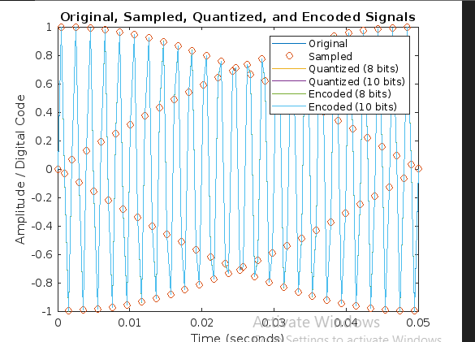

Original signal:

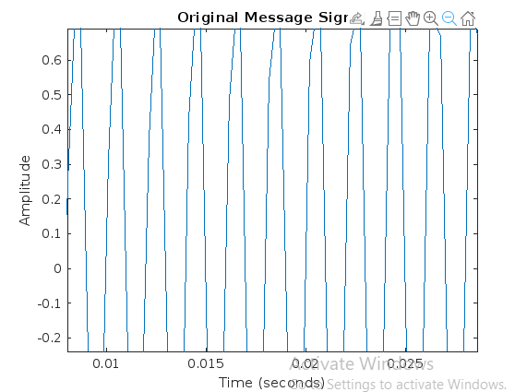

Sampled

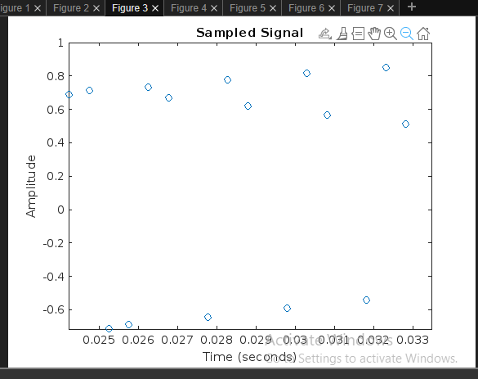

Quantized 8 bits:

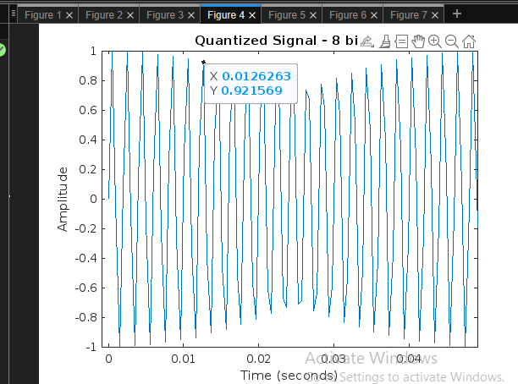

Quantized 10 bits:

Encoded:

Encoded 10 bits:

All in one graph:

